26/05/2015

# Simplified Thermal model

A simplifed thermal model is reported in the following, the baseline assumptions are:

* Only stator joule losses are condidered.
* Only radial heat transfer is considered, no 3D effect is taken into account, end winding connection are consiedered only in Joule losses computation but not in heat transfer.
* rotor heat exchange trough the axial dimensionis neglected:iheat flows from slot to frame radially.
* Frame temperature is imposed.

In Fig 1 the different portions of stator are reported: teeth, yoke, slot and the interconnection between them.

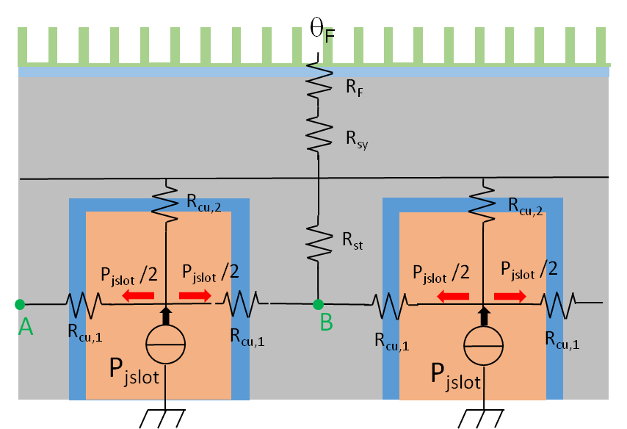

1. Equivalent thermal resistance connection for stator slot and iron

Assuming that thermal transients are really slow compared to electrical ones, it is possible to assume that point A and B shown in Fig 1 are at the same temperature. Therefore, it is possible to simplify the circuital model, using the one represented in Fig 2.

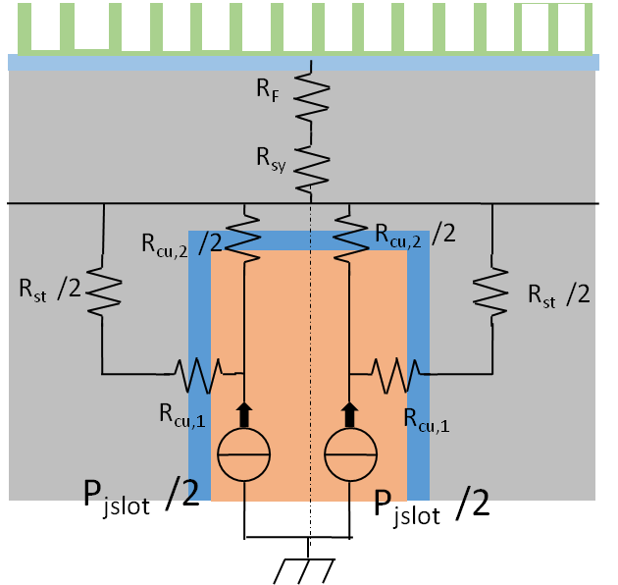

1. Equivalent single side thermal circuit representation

## Joule loss computation from slot Current density *Jslot* [A/mm2]

Joule losses are computed in function of stator geometry and slot current density.

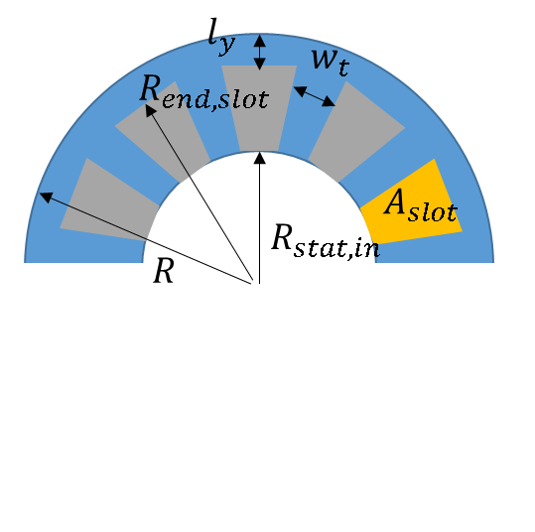

1. Main stator dimension

Tooth width



Yoke length



Distributed winding, end winding computation



*Kw,sh* shortening factor.

Fractional slot winding, end winding computation



Approximate slot area calculation



Joule losses:



## Equivalent global thermal machine model

In Fig 4 is reported the final version of the equivalent circuit model, this model is representative of all the machine, meaning that the different resistive contribution are representative of the all machine volume.

All slot are condensate in one where are dissipated all the Joule losses and with equivalent slot resistance equal to the parallel of all slot resistances, also the teeth resistance are computed considering all the teeth volume in the machine.

The slot is supposed divided in two portion an inner area, *Acu,1*, and an outer area *Acu,1*. The power production is divided according to the area.

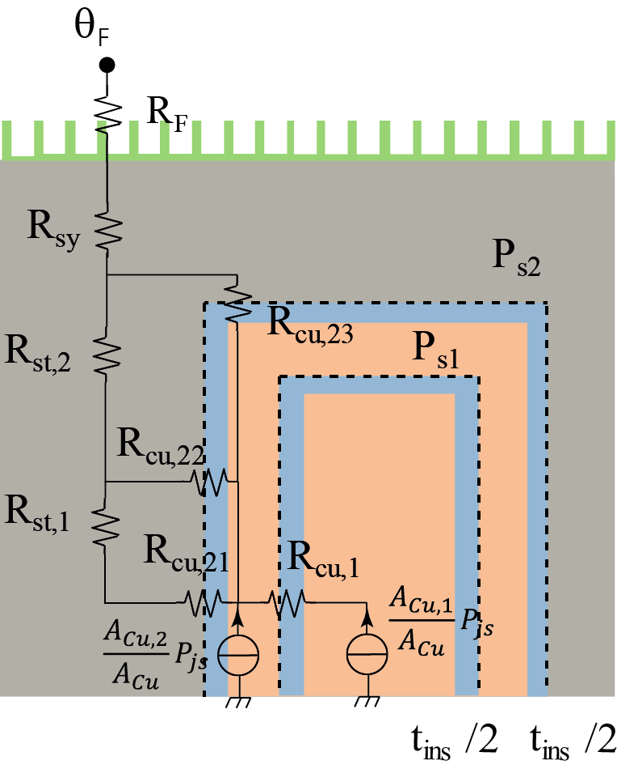 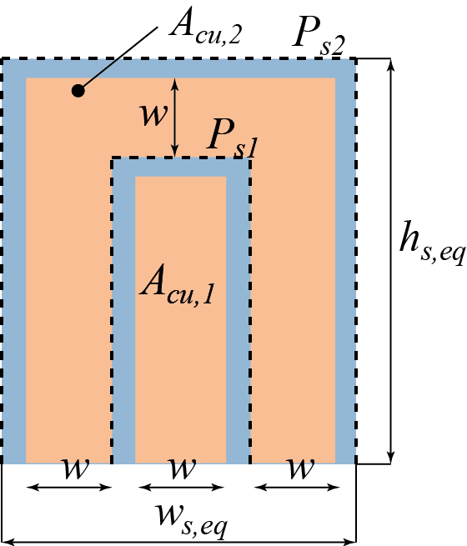

1. (b)
2. Equivalent full machine thermal model

Stator yoke thermal resistance



Stator tooth:

Tooth resistance is divided into two component, one representing temperature drop at the middle of the tooth, and second one representing the drop between the middle and the end of the tooth.







FE : iron thermal conduction coefficient.

*l*: stack length.

Stator yoke to frame thermal resistance



*hc*=frame core contact coefficient 1000W/m2°C

In stator slot modeling in order to simply the analysis an equivalent rectangular slot is used instead of the original trapezoidal one, see Fig 5.

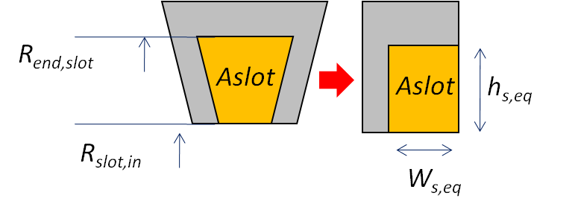

1. From trapezoidal slot to rectangular slot

Equivalent rectangular slot





External insulation perimeters shown in Fig 4 is computed in the following



Total insulation in slot



Total insulation thicknessis divided in equal parts between the inner and outer insulation layer (Hypothesis).



Copper thickness is assumed equal for the three copper segment (Hypothesis), see Fig 4.



Internal insulation layer perimeter and area



$$A_{s1}=w\left(h_{s,eq}-t_{ins}-w\right)$$

Inner insulation layer, thermal resistance



Inner layer is modeled by a single resistance with an equivalent conduction area equal to all *Ps1l*

Outer insulation layer formulated like in Fig.2 is the parallel of the resistances on the right and left side of the slot; this is the meaning of the initial ½ in formula.



The outer insulation layer is divided into two component, representing the half side of the slot.



The end of the slot is modeled by a single resistance directly connected to the yoke.



Nodal analysis is used to calculate the temperatures in all the nodes of the circuit in Fig. 6.

The matrix equation to be solved is:

 (MATR1)

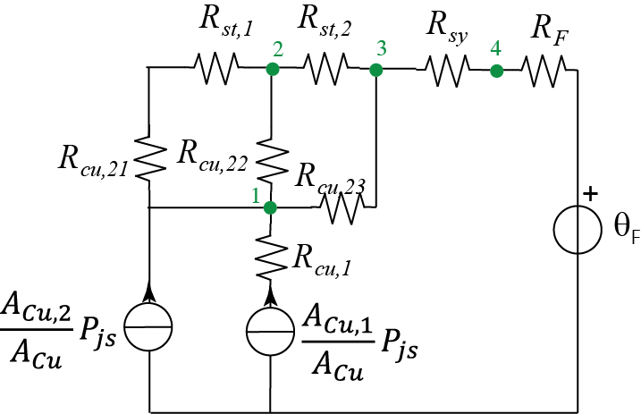

1. Eq thermal network







Nodes 1 and 2 are not included into the system of equations (MATR1). They can be solvedseparately, after the solution of (MATR1):





From the solution of the nodal analysis is possible to compute the nodal temperature in nodes evidenced in Fig 4.In Fig 6,7 a comparison with 2D thermal FEA are shown, in the case of full distributed winding q=2 the division of the slot in two insulation layer seems not necessary.

In Fig 7 instead, for fractional slot motors is evident that the division of slot into two insulation layer one internal and one external permits to obtain better approximation to the FEA results.

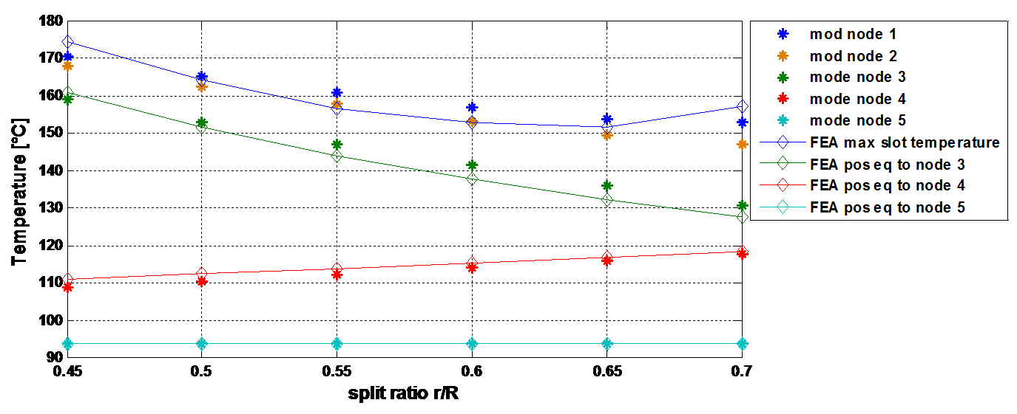

1. Comparison between FEA Therm and simplifed model for q=2 motor imposed Jole losses @20*C Pjs=1000W

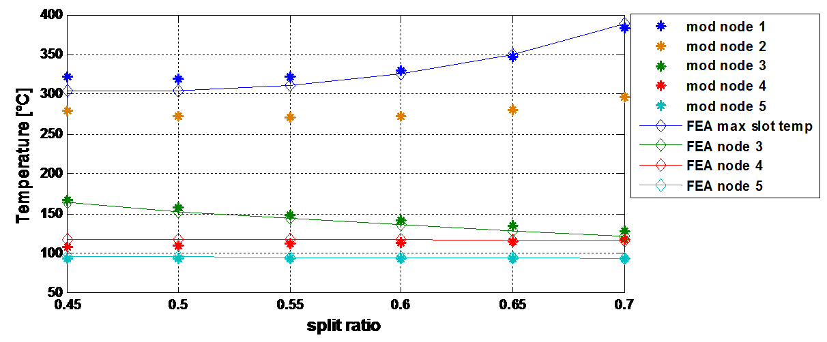

1. Comparison between FEA Therm and simplifed model for q=1/2 motor imposed Joule losses @20°C Pjs=1000W

FEA slot are modeled by the homogenization theorem, iron temperature are well matched, modelslot temperaturepresents a variation respect to FEA with maximum excursion of 5%.

Model tend to be conservative respect to the FEA, temperature are generally higher.

In Fig 9 are evidenced the temperature point compared with the model in FEA solution.

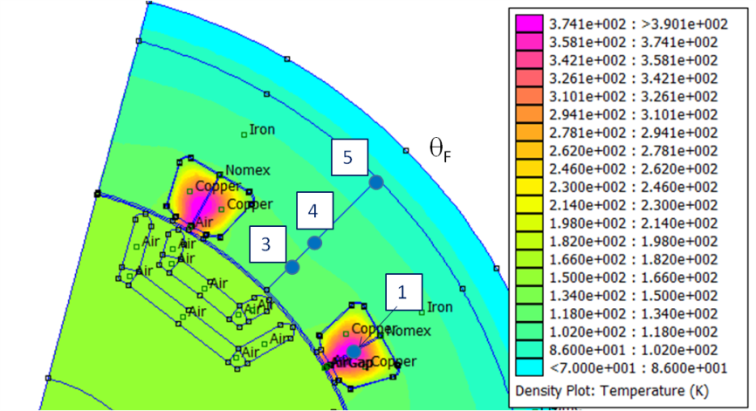

Fig 9: example of FEA temperature measure for comparison with simplified model